UI Design and Prototyping Report Template

1. Introduction
The main goal of my project is to create a map, which will automatically generate the most suitable routes for skating (excluding bad or repaired roads and having regards to skaters experiences). My project will include next features.

List of Features
- Registration

-Users will have the possibilities to add their routes and information about roads condition

-Automatically generated routes

-Special layers with location of shops and skating parks

2. User Interface Design and Prototype
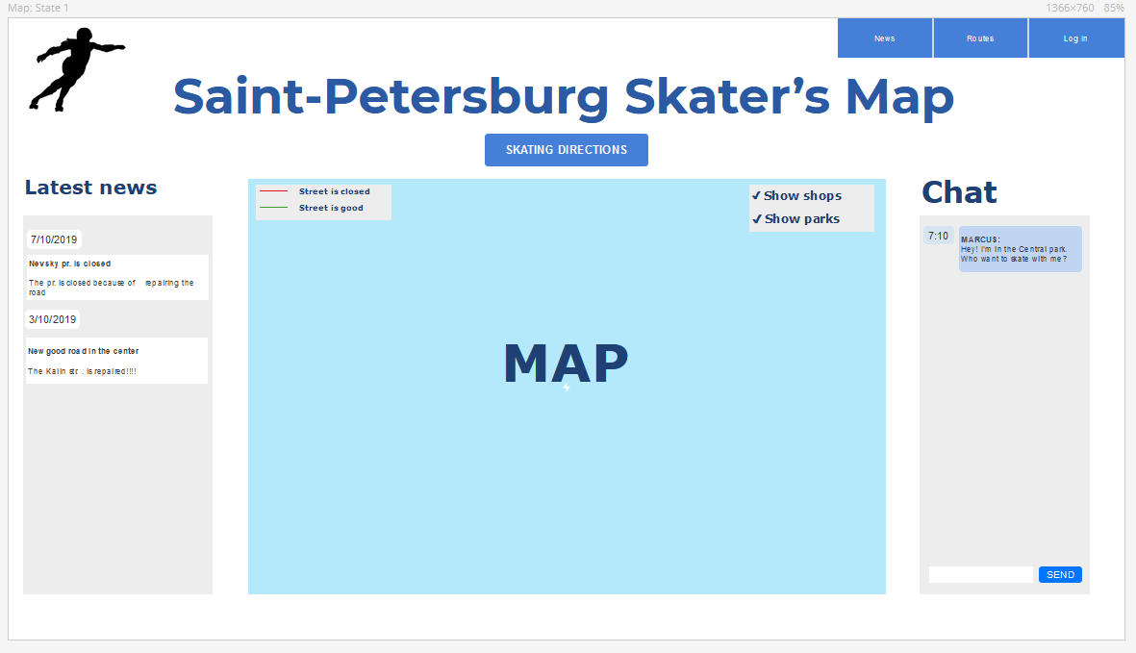
At the main web-site page there are screens with latest news and chat, where visitors can discuss the routes, or invite other visitors to skate. I use button for the feature - automatically generated routes. This button will open a special form, where people can add their start and end point of their route and add some special conditions (without bridges, hills, show shops and parks).
In the right corner there is a navigation bar with links for News and Routes pages and registration/log in forms.
In the center there is a map with legend (showing bad and good streets designation) and possibilities to turn on layers with parks and shops.
The most important thing is that all features are available for visitors at the main page (registration, routes, news, shops and parks on the map). And the most important information (latest news) is also at the main page. So visitors see all they need and they should try to find features among many pages (because we have just three pages).
I also added forms for registration, log in, adding news and routes and etc.

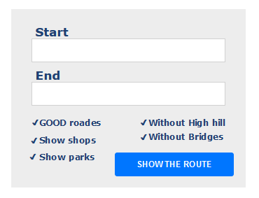
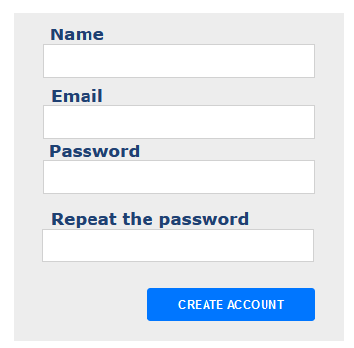

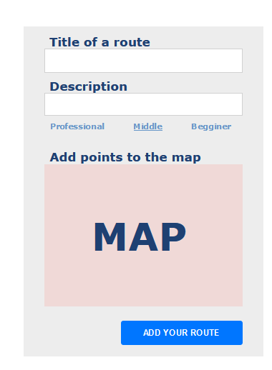

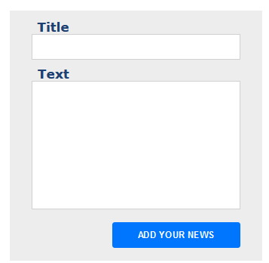

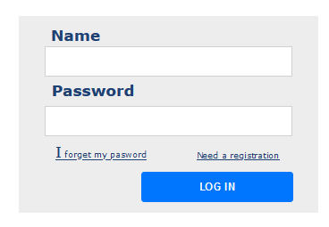

3. Navigation Structure
To show my navigation structure, I made a prototype of my application (https://pr.to/SFVJQP/ ).
From the main page we can go to the Routes page and News page. We can also open automatically generated routes form and registration form. From these forms we can return to the map.
On the Routes page we can choose interesting route and try it. After that we will return to the map and will see the chosen route. We also can add the new route – click on the button will open the Add route form. Click on the logo in the right corner will return us to the map.
On the News page we can add the news clicking on the button and opening Add news form. Click on the logo in the right corner will return us to the map.

4. References

- https://proto.io/
- https://en.wikipedia.org/wiki/User_experience - User experience from Wikipedia
- https://freshdesignweb.com/css-registration-form-templates/ - Sign up and Registration forms
- https://yoast.com/site-structure-the-ultimate-guide/ - Site structure

